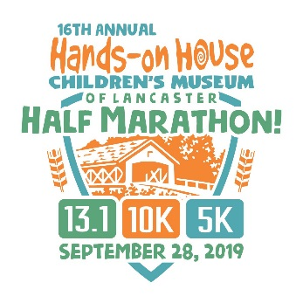
Sponsorship Commitment Form
The 16th annual Half Marathon, 10K & 5K to benefit Hands-on House Children’s Museum of Lancaster is scheduled for Saturday, September 28, 2019. As Lancaster County’s original half marathon, plus two shorter distances, the event has a well-established place on the local running calendar. We continue a robust plan of marketing to the general public locally and to the running community in the mid-Atlantic region. All proceeds directly support Hands-on House programs and exhibits.

Please complete the following form and return it with payment as instructed below.

Sponsor’s name: ___________________________________________________________________________
(as it should appear on signage and other collateral)
Contact name: _____________________________________________________________________________
Street address: _____________________________________________________________________________
City, state, and zip code: _____________________________________________________________________
Phone: __________________________________ Alternate phone: _________________________________
Email: ____________________________________________________________________________________
Website: __________________________________________________________________________________
Facebook: _____________________________________________ Twitter: ___________________________

Sponsorship Level:

___ $5,000 Title Sponsor
___ $3,000 Refreshment Sponsor
___ $3,000 Safety Sponsor
___ $1,500 Timing Sponsor
___ $1,500 Pace Car Sponsor
___ $750 Bridge Sponsor
___ $750 10K Turnaround Sponsor
___ $350 Booth Sponsor
___ $350 Golf & Run! Sponsor
___ $250 Mile Sponsor

Payment Method:
___ Check (made payable to Hands-on House Children’s Museum of Lancaster)
___ In-kind donation

Thank you for your support!

Please retain a copy of this form for your records and remit this form along with payment to:
Hands-on House Children’s Museum of Lancaster
ATTN: Race
721 Landis Valley Road, Lancaster, PA 17601

Questions? Contact Becca Stamp, Development and Community Relations Coordinator,
at (717) 569-5437 Ext. 228 or becca.stamp@handsonhouse.org

Hands-on House Children’s Museum of Lancaster is a nonprofit educational center whose mission is to create landmark learning experiences for children and their families through play.

